**3- Write a JSF project which contains 2 web pages the first page is called *index.xhtml*, and contains a Login form as shown below.**

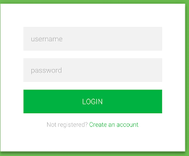

**and the second page called welcome.xhtml displaying a welcome message if the user is a registered one when the LOGIN button pressed .**

**You must do the following :-**

**1- Create a class called Account.java represent an account with 2 attributes**

**Username (String) , password (String)**

**2- Create a managed bean called user.java with an array of accounts called accounts contains the following data**

|  |  |
| --- | --- |
| **Username** | **password** |
| **rahmed** | **123A45** |
| **mali** | **125N38** |

**3- Your application should validate that the entered value in the password field has a minimum length 6**